United States

## Political Stability Estimate Data

The data set shows the political stability estimate of the country each year.

## # A tibble: 19 x 5  
## country iso3c date stability stabilityCategory4   
## <chr> <chr> <dbl> <dbl> <chr>   
## 1 United States USA 1996 0.936 moderately stable   
## 2 United States USA 1998 0.880 moderately stable   
## 3 United States USA 2000 1.08 highly stable   
## 4 United States USA 2002 0.288 moderately stable   
## 5 United States USA 2003 0.0813 moderately stable   
## 6 United States USA 2004 -0.231 moderately unstable  
## 7 United States USA 2005 -0.0587 moderately unstable  
## 8 United States USA 2006 0.494 moderately stable   
## 9 United States USA 2007 0.376 moderately stable   
## 10 United States USA 2008 0.585 moderately stable   
## 11 United States USA 2009 0.448 moderately stable   
## 12 United States USA 2010 0.438 moderately stable   
## 13 United States USA 2011 0.591 moderately stable   
## 14 United States USA 2012 0.632 moderately stable   
## 15 United States USA 2013 0.643 moderately stable   
## 16 United States USA 2014 0.582 moderately stable   
## 17 United States USA 2015 0.678 moderately stable   
## 18 United States USA 2016 0.402 moderately stable   
## 19 United States USA 2017 0.305 moderately stable

## Political Stability Estimate Plot

The plot shows the trends of stabilization and destabilization for the each country.

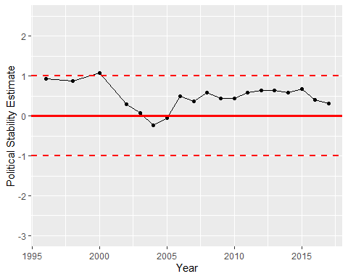

Political Stability Trend